

**Name of the Course:** Information Technology Programmer Analyst.

**Name of the Teacher:** Zohreh Moeini

**Name of the Student:** Ramya Modepalli

**Contents**

**Introduction:** 3

**Main Characters:** 3

**Production:** 4

**Filming:** 5

**Soundtrack:** 5

**Plot:** 6

**Editing:** 7

Bibliography 7

**SHIDDAT**

# **Introduction:**

**Shiddat**: Journey Beyond Love, or simply Shiddat (transl. Passion), is a 2021 Indian Hindi-language romantic drama film directed by Kunal Deshmukh and produced by Bhushan Kumar, Krishan Kumar and Dinesh Vijan under their banners T-Series and Maddock Films. The film stars Sunny Kaushal, Radhika Madan, Mohit Raina and Diana Penty.

The film starts with the wedding ceremony of Gautam and Ira [fellow mates at French university]. Jaggi, a drunk guest at the wedding, creates a scene and gets caught with his friends for gatecrashing the party.

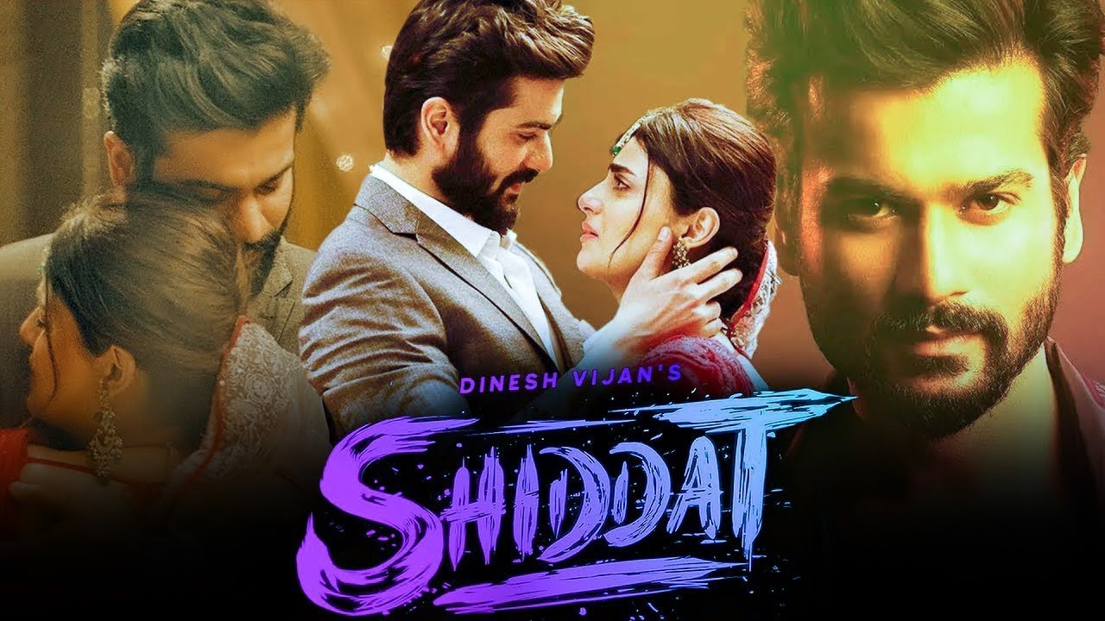

Figure 1 Poster of the movie

## **Main Characters:**

* Sunny Kaushal as Joginder Dhillon "Jaggi"
* Radhika Madan as Kartika Singh
* Mohit Raina as Gautam Sehgal
* Diana Penty as Ira Sharma Sehgal
* Arjun Singh as Ketan
* Vidhatri Bandi as Sheena
* Gaurav Amlani as Pinkesh
* Gandharv Dewan as Rana "Rane" Chaudhry
* Chirag Malhotra as Bilal

**SHIDDAT**

## **Production:**

The film was announced on 16 May 2019 by Dinesh Vijan. Dinesh Vijan is an Indian film producer and director who works in Hindi films as well as a few English Films. He is the founder of Maddock Films. He gave up his banking job in 2004 to pursue films. He has produced critically and commercially acclaimed films such as Stree, Hindi Medium, Luka Chuppi, Badlapur, Love Aaj Kal, Cocktail and Bhediya.

Radhika Madan is an Indian actress who works in Hindi films and television. Madan is a recipient of several accolades including a Screen Award and a Filmfare OTT Award. Madan was featured by Forbes India in their 30 Under 30 list of 2024.

Sunny Kaushal (born 28 September 1989) is an Indian actor who works in Hindi films. Born into the Kaushal family, he worked as an assistant director on the films My Friend Pinto (2011) and Gunday (2014). He made his acting debut in the comedy-drama Sunshine Music Tours and Travels (2016), and gained recognition for his supporting part in the sports biopic Gold (2018). Kaushal has since starred in the streaming series The Forgotten Army - Azaadi Ke Liye (2020) and films Shiddat (2021) and Chor Nikal Ke Bhaga.



Figure 2: Souls of the Movie

### **Filming:**

Principal photography is the phase of producing a film or television show in which the bulk of shooting takes place, as distinct from the phases of pre-production and post-production.

**The Love**

# **Soundtrack:**

The film's music was composed by Sachin–Jigar, Manan Bhardwaj and Gourov Dasgupta while lyrics written by Kausar Munir, Priya Saraiya, Kunwar Juneja and Manan Bhardwaj. The song Akhiyan Udeek Diyan is a remake of Nusrat Fateh Ali Khan's 1993 qawwali song.Kohinoor Mukherjee, mixing and mastering engineer received 'Best Mixing Mastering Award' for Hum Dum Song.

Sachin–Jigar are an Indian music composer, singer, music producer, music director and arranger duo consisting of Sachin Sanghvi and Jigar Saraiya. They compose for Hindi and Gujarati language films. Before working independently as music directors, they served as orchestrators for Pritam.

 

## **Plot:**

The film starts with the wedding ceremony of Gautam and Ira [fellow mates at French university]. Jaggi, a drunk guest at the wedding, creates a scene and gets caught with his friends for gatecrashing the party. Jaggi crosses the border illegally, intending to reach London, but gets caught and taken back to the embassy [where Gautam works]. Jaggi explains that he has to reach London before Monday to prove his love, after being inspired by Gautam's speech on reception day. The film flashes back to three months ago.





## **Story:**

Jaggi crosses the border illegally, intending to reach London, but gets caught and taken back to the embassy [where Gautam works]. Jaggi explains that he has to reach London before Monday to prove his love, after being inspired by Gautam's speech on reception day. The film flashes back to three months ago.

Jaggi, a hockey player, meets Kartika, a swimmer, and though the two get off to a rocky start, they start spending time together and grow close. But Jaggi finds out Kartika is getting married. She asks him meet her after three months in London, to prove that his love are true, in which case she would cancel the wedding. Jaggi enters the UK illegally and faces many hurdles trying to reach Kartika before her wedding and after falling off a plane Jaggi dies leaving Kartika heartbroken. The film ends with Kartika along with Gautam, Ira and all their friends trying to celebrate Jaggi's life, remembering him.

### **Editing:**

Akkineni Sreekar Prasad is an Indian film editor known for his works across Hindi, Malayalam, Tamil, and Telugu language films. In a career spanning more than 35 years, he has edited over 600 films.He is a recipient of nine National Film Awards including seven wins for Best Editing which is a record in that category. He also won five Kerala State Film Awards, two Andhra Pradesh state Nandi Awards, and four Filmfare Awards among others.

# Bibliography

Prasad, S., 2021. SHIDDAT. *The Love Story,* 1 October, Volume 1, p. 50.